ELEC 5220/6220 Information Networks and Technology  
LAB 4 REPORT

Xiao Lin & Jie Zou

# Abstract

In this lab we are beginning to learn how to using the JavaScript validate user's input and submit the data to server side and process. The advantage of JavaScript is that it is a script language which is easy to use, and it can be independent or embedded into HTML codes to interact with user in the browser.

# Introduction

In this lab, we usu the JavaScript to validate user's input such as zip code, username, email address and so on. In the JavaScript we use the regular extension to check whether the input is correct. We also use the JavaScript to submit data to server and update the web page.

# Design

Validating Zip Codes

Here are figures to test the codes validating zip code

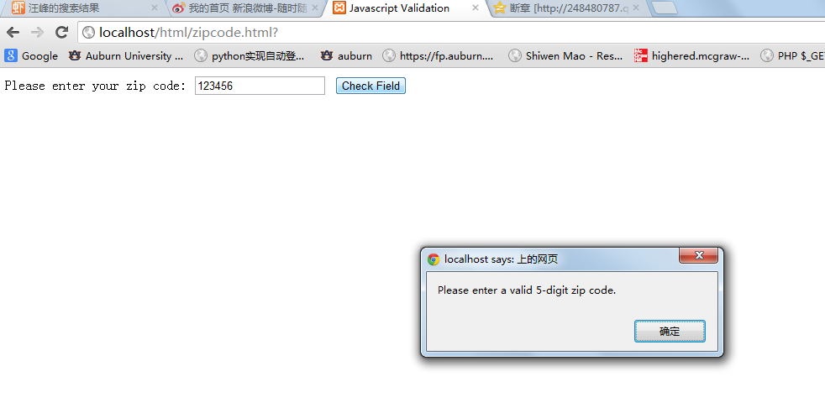

Figure1: enter 6 digital lead to a alert

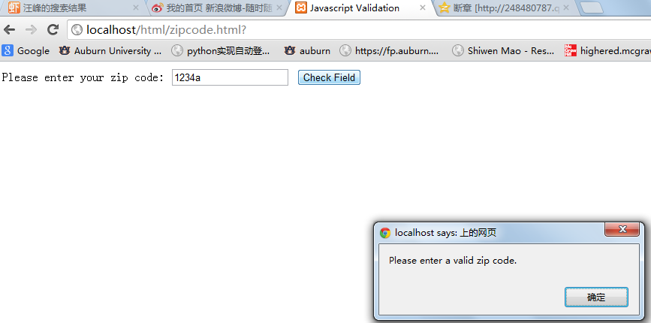

Figure 2: enter five digital mixed with letter

Here are the figures to show the test results of username validation:

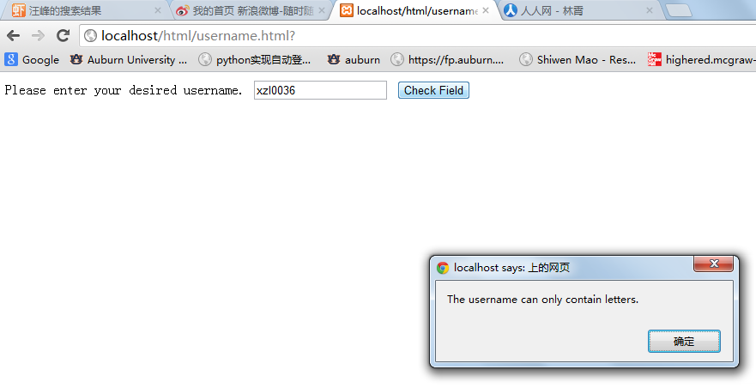

Figure 3: enter letters mixed with digit as username

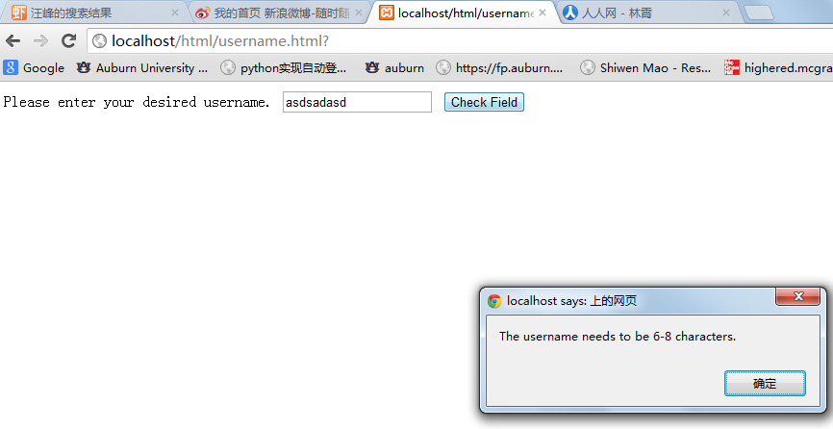

Figure 4: enter username longer than 8 characters

Here are figures to show the test results of email address validation:

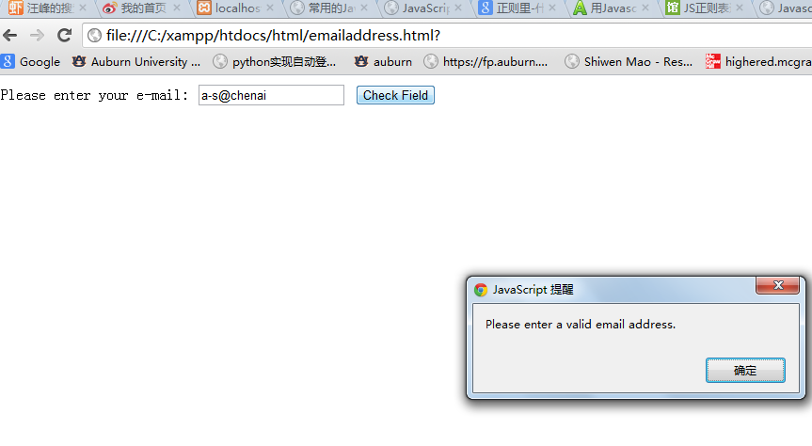

Figure 5: the incorrect format email address

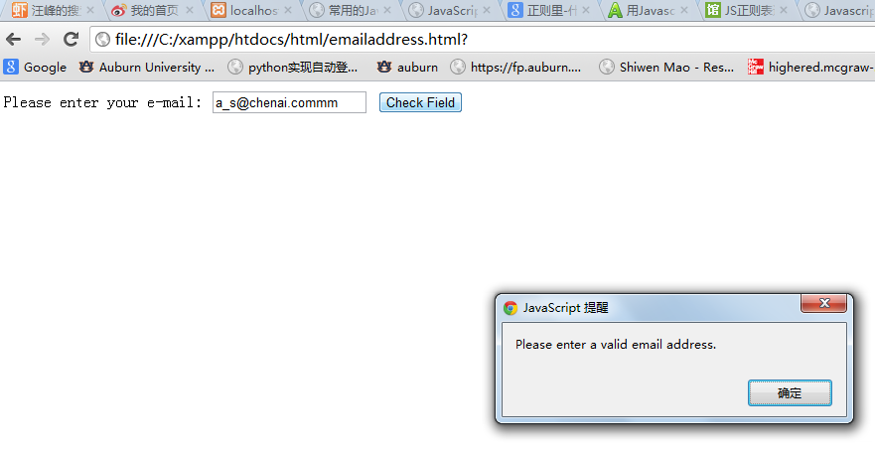

Figure 6: the incorrect format email address

And then we combine PHP with JavaScript and use JavaScript get the input data, here are the figures showing the test result:

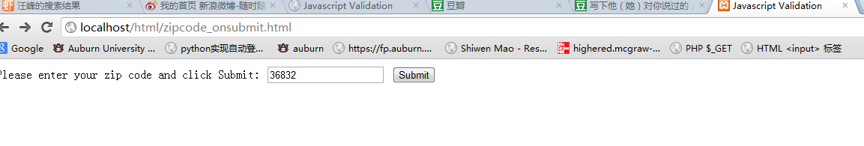

Figure 7: enter a valid zip code and click Submit

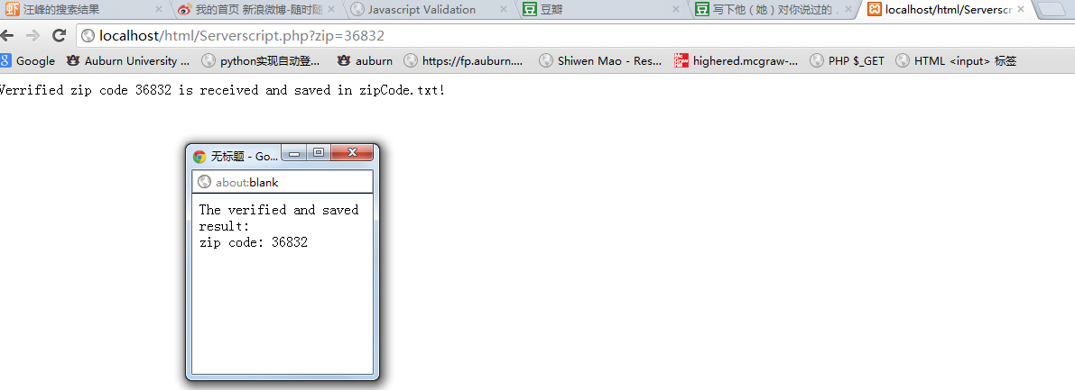

Figure 8: it will turn to another page and there will be a pop window to show the data received

And we try to use another method to validate the input and pass data to server, the method is onblur, here are the figures to show the test result:



Figure 9: enter zip code in text box before we click the tab, we validation status is unknown

And then we click the tab:



Figure 10: after clicking tab validation status changed

And if we enter a incorrect zip code there will be a alert:



Figure 11: invalid zip code

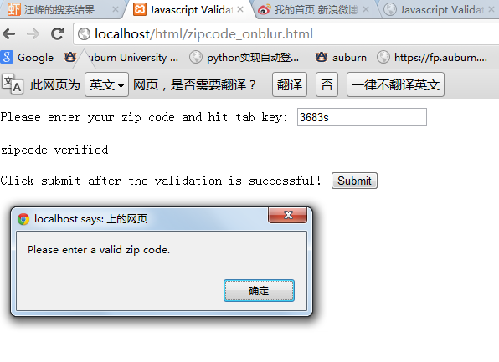

Figure 12: invalid zip code as well

And we enter a valid zip code and click submit

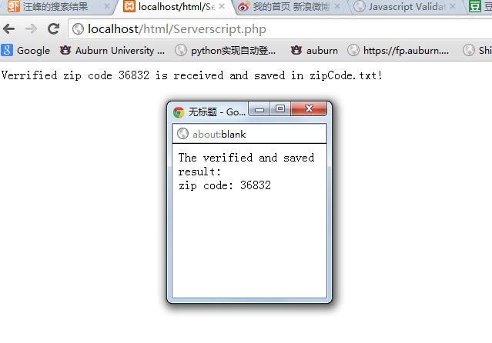

Figure 13: validation successfully, server get the data

And now we try to use onblur method to validate two input and how the validation result in the page, here are the result figures:



Figure 14: before we enter the validation status is unknown

And we enter a valid username in the text box and click the tab:



Figure 15: we enter the username XiaoLin, the validation status changed

And then we enter a valid zip code:



Figure 16: enter zip code 36832, the validation status changed

And if we click the submit button we will turn to the server page. In server we will show the data entered by user and save the data into a txt file in xml format, here are the figures showing the result:



Figure 17: the server page, pop window and the txt file showing the data received

In our own exercise, we are going to write a file: 4-f.html and 4-f.php. 4-f.html page is used to let user input the name, telephone number and address, we will use onblur method to validate the entered information in 4-f.html, and if we click the submit button, the data will be sent to 4-f.php, in this page, we will show the received data in the main page and in a pop window, besides we also will save the received data into a txt file in the xml format, here are the figures showing the result:



Figure 18: enter valid information and click the submit button

After we have entered the information and click the submit button, we will turn to the server page showing the received data and do some other wok:

Here are the figures of test result:



Figure 19: the server page will show the data received, popping a new window and save the data into a txt file in xml format.

# Result

In this lab we have learned how to use JavaScript to validate the information entered by user and pass the information to server by two different method, that is onsubmit and onblure. And in the server side code, we have learned how to save the information into a txt file in the xml format.

# Conclusion

In general following the lab guide, it is easy to finish all of the lab. By scanning the w3school in the web, we have know that the JavaScript is mainly used as a client side programming language, and the PHP is use as a server side language. With combining these two language together, we are able to improve the experience of user who is scanning the web site. And in this lab, another important matter is the regular expression. I have learn python and I know the regular expression is important in web programming and in the search technologies. And what is possibly difficult is also the regular expression, because we should get the right regular expression to check the user inputs.

# References

* Lab guides offered by Dr. Wu and the explanation of GTA Mr.Hou
* HTML 4.0 Specification, <http://www.w3.org/TR/html4/>
* W3school,<http://www.w3school.com.cn/>
* PHP, <http://www.php.net/>
* Javascript, <http://www.javascript.com/>